1. SIT env is used to do **login->product list->logout** PT:

<https://10.112.179.177:10003/breeze-tenpay-sit/index.html#brz-login>

1. Open this url, login and logout, then you can see the request and response for each step.

The request for **generate**:

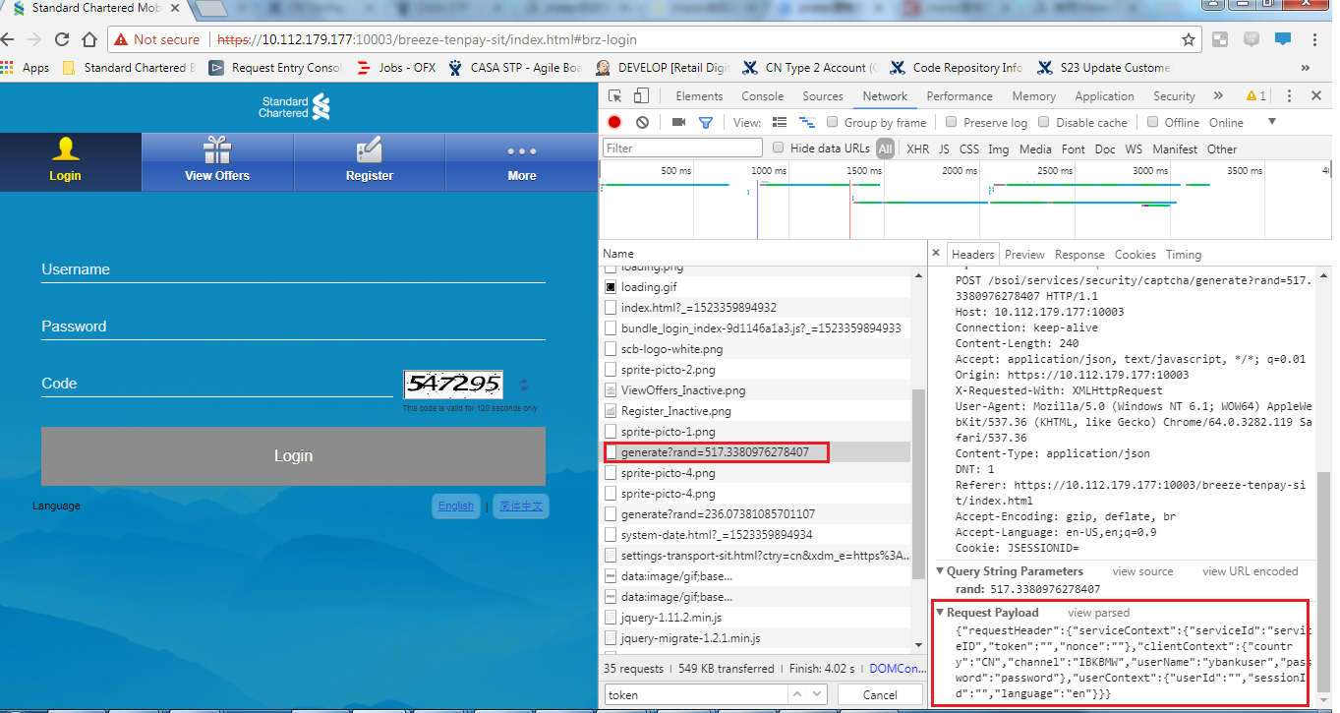

The response for **generate**:

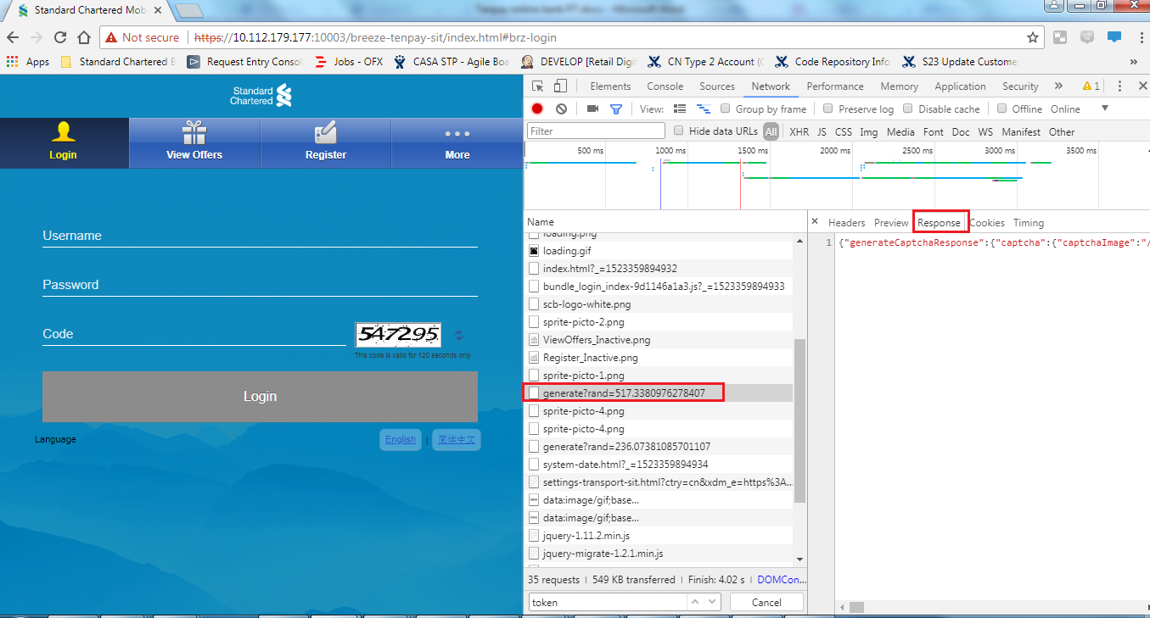

The same operation for **login**, **productList** and **logout**:

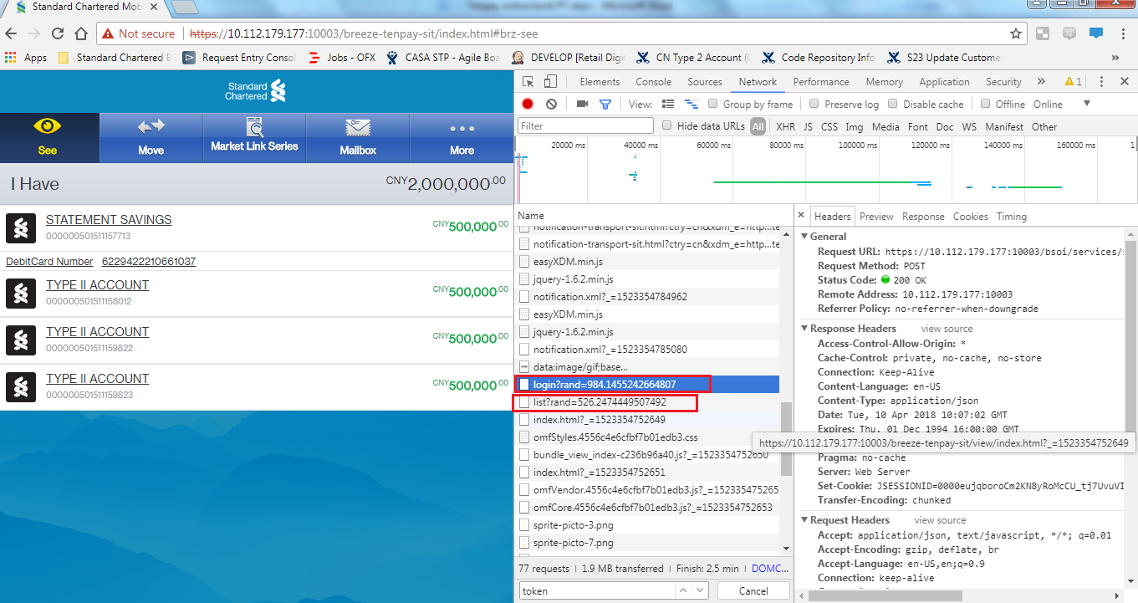

Logout

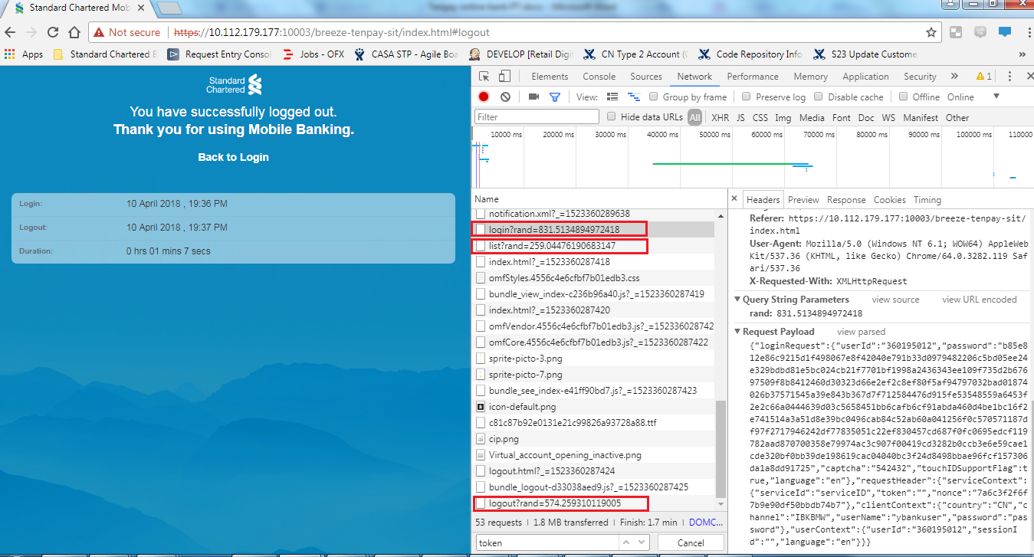

Through these request and response parameters we can get:

1. There are some stable parameters, such as “serviceId”, “country”, “channel”;
2. There are also some changing parameters which is obtained from previous step:

from **generate** response, we can get the **login** request parameter “captcha” and “nonce”;

from **login** response, we can get the **productList** request parameter “nonce” and “sessionId”;

from **login** response, we can get the **logout** request parameter “sessionId”;

from **productList** response, we can get the **logout** request parameter “nonce”.

The **login** request parameter “captcha” is a string but the parameter “captchaImage” obtained from **generate** response is base64,

Can this parameter be by pass?

The **login** request parameter “password” also need to be by pass because password in request is encrypted.

And the productList and logout request parameter “token” may be generated from backend? This parameter can be also by pass.

1. Setup PT script:
2. Add HTTP request Defaults:

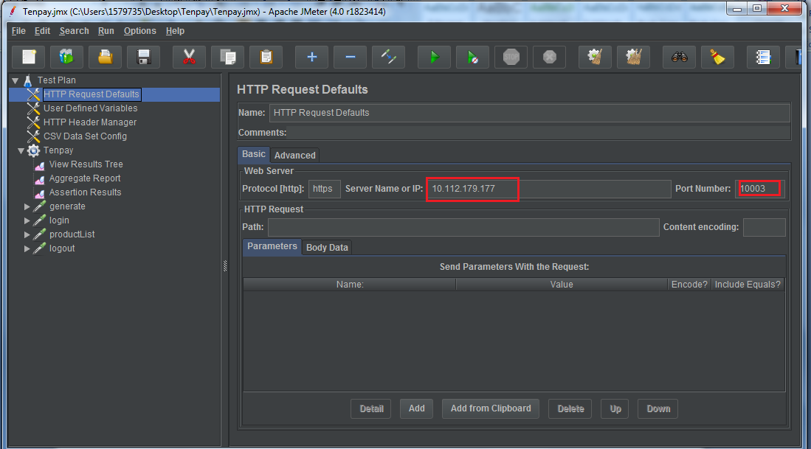

1. Add user defined Variable for these stable parameters:

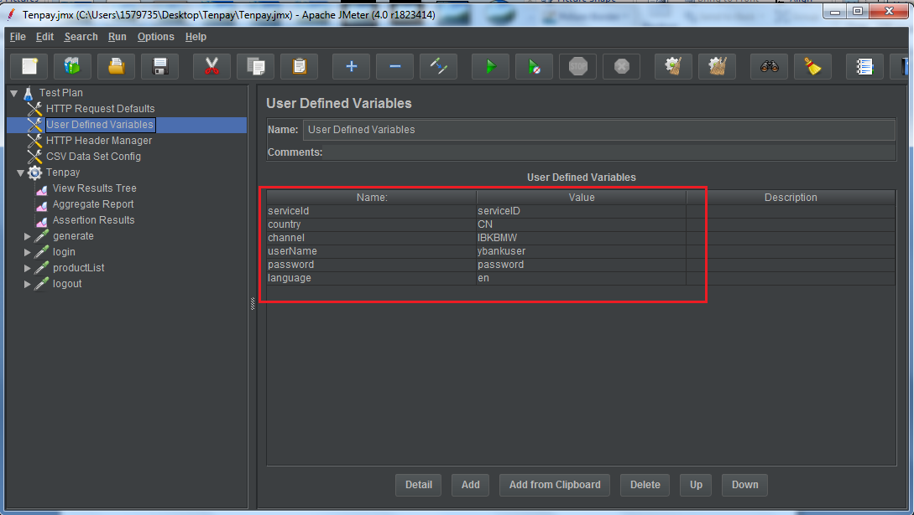

1. Add HTTP Header Manager:

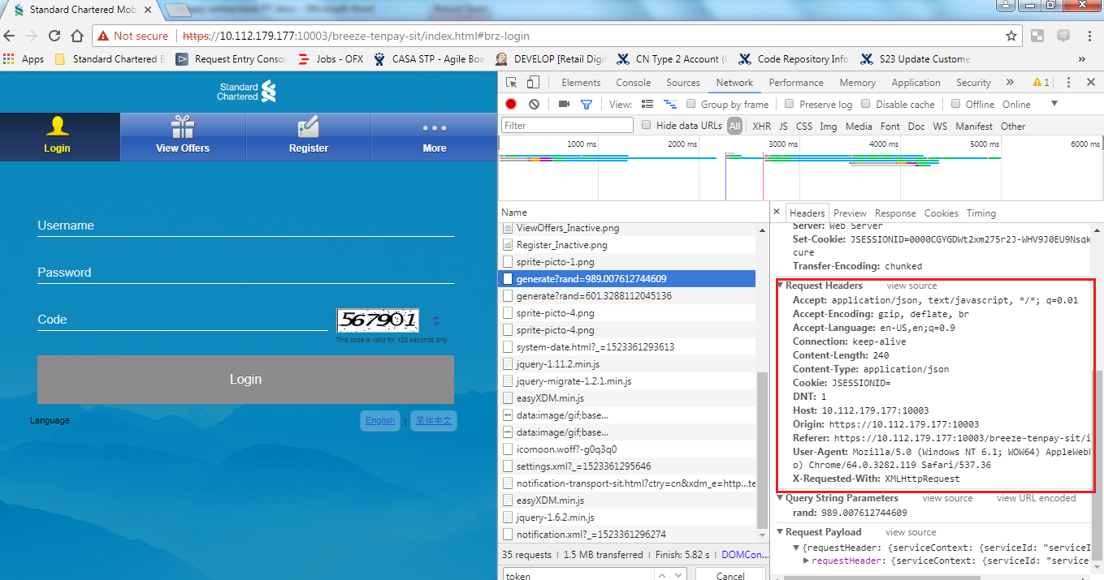

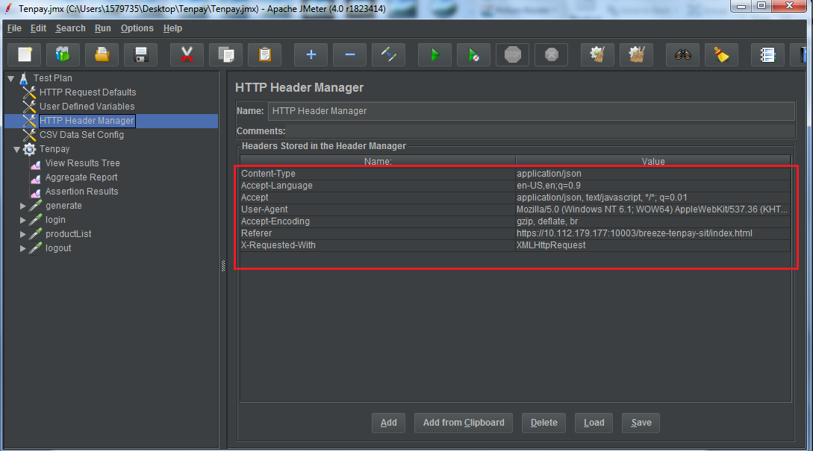

1. new a csv file and input the userId/password

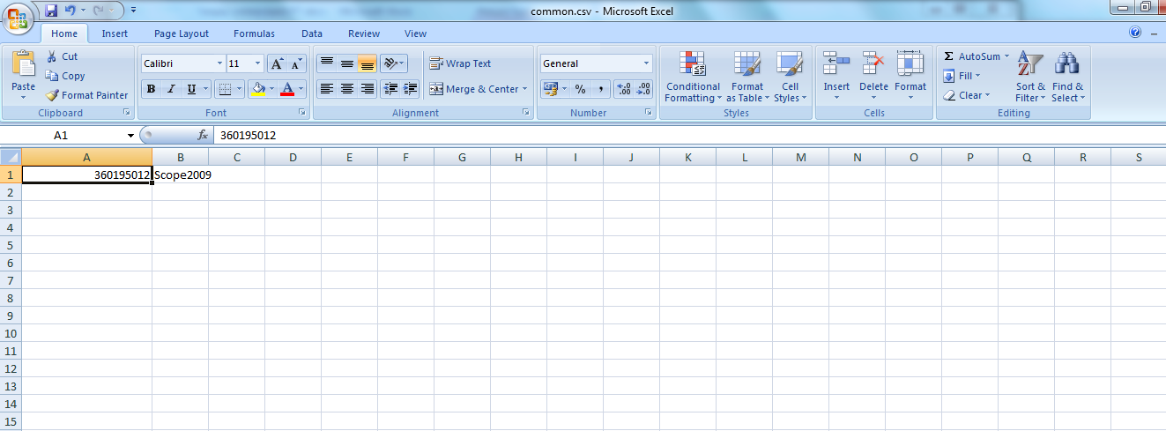

Add CSV Data Set Config and select the file path:

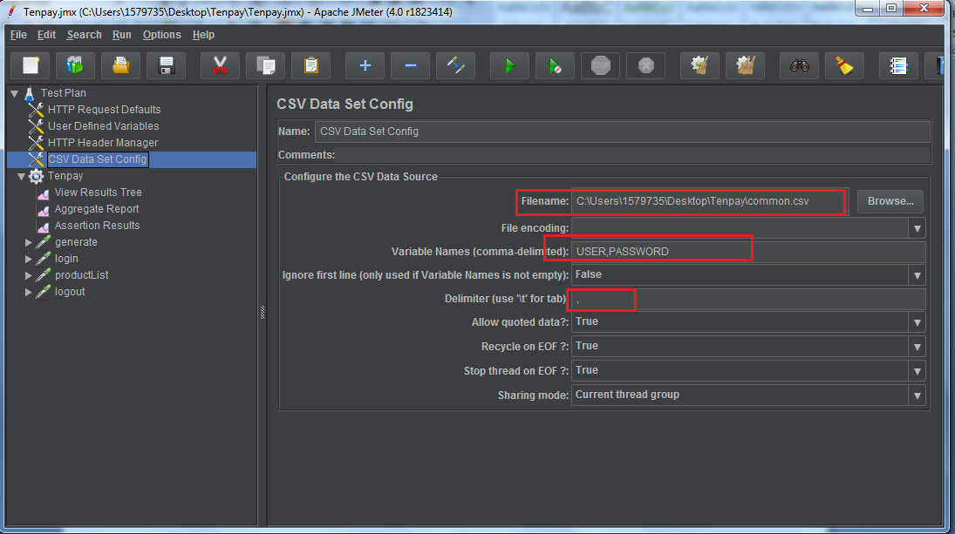

1. add Thread Group and you can set number of users, ramp-up period and loop count here.

add some listener to view the results:

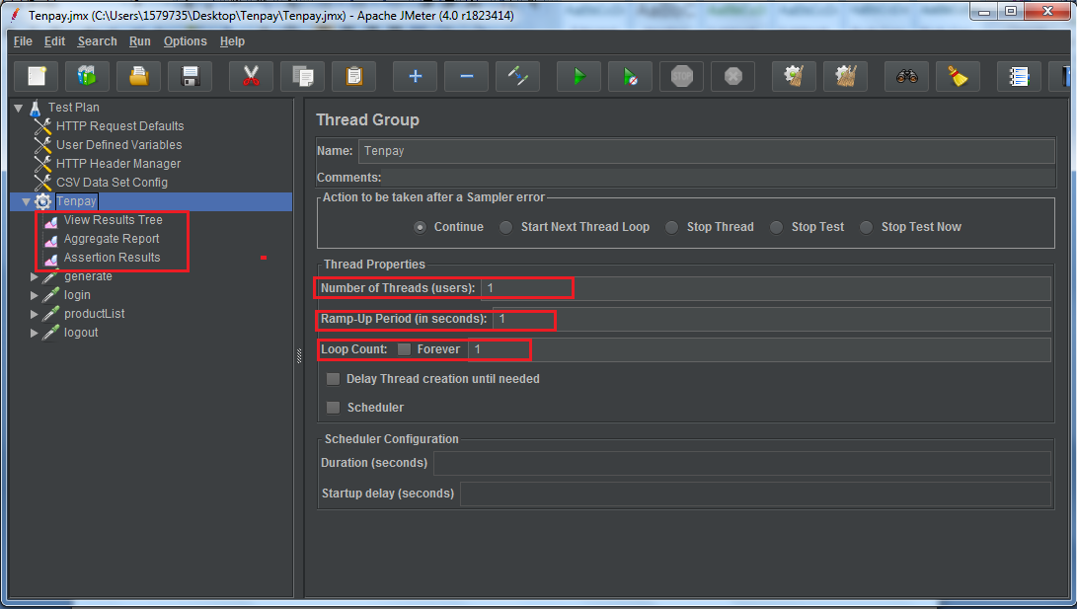

1. Add HTTP request for **generate, login, productList** and **logout**.

Take **generate** as an example:

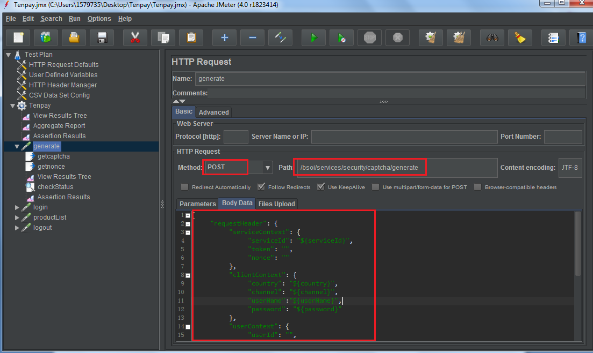

Because in next step we have to use the parameter “nonce” in **generate** response, add Regular Expression Extractor to get “nonce”.

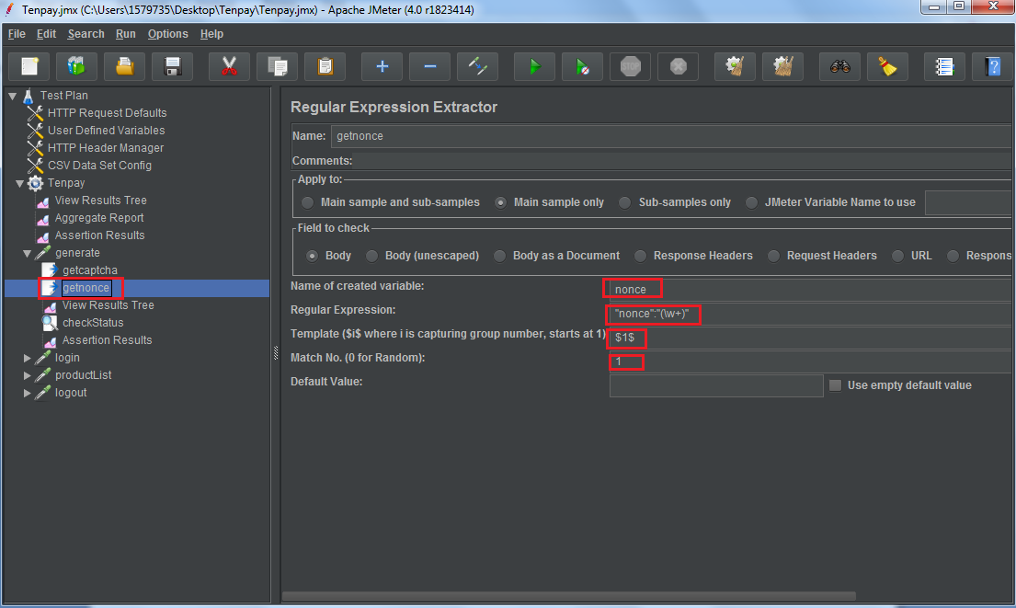

Add Response Assertion to check the parameter “status”:

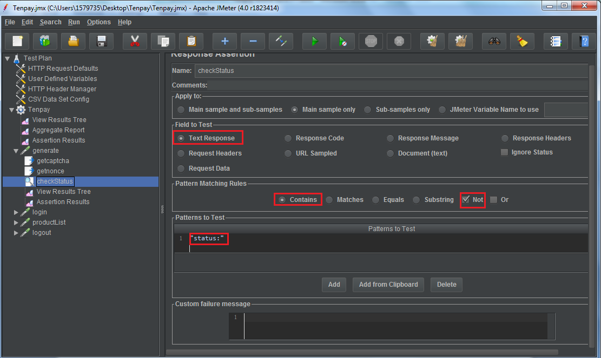

The same operation for **login**, **productList** and **logout**:

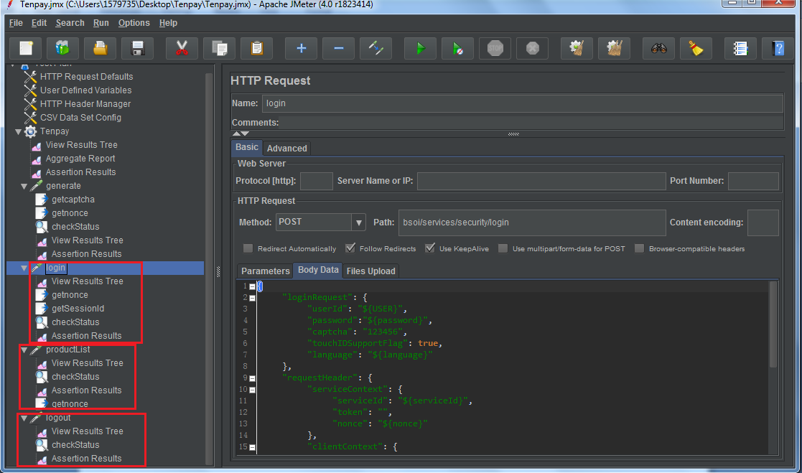

1. the jmx script will be generated and next time you want to test this service, you can just drag the script to the box.